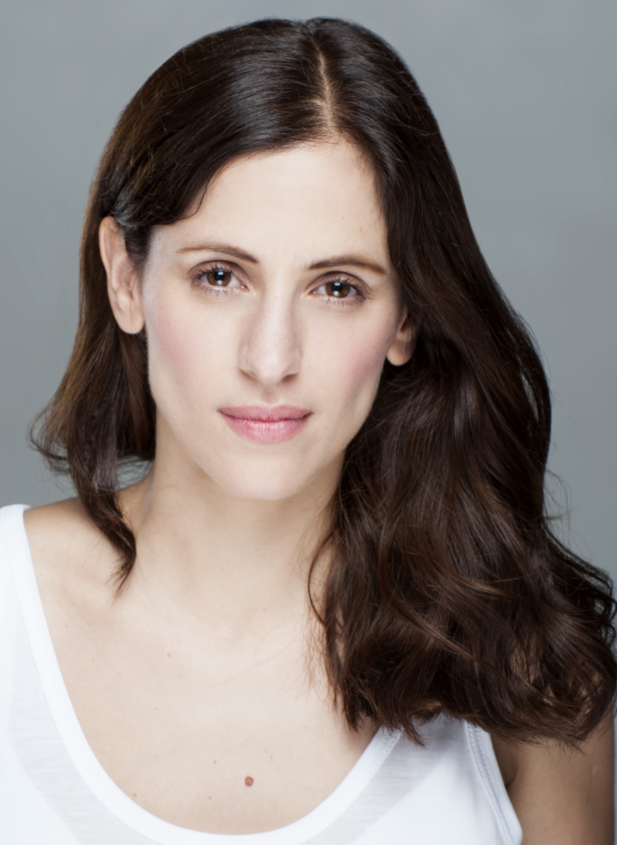
Sara Ballesteros

Email: ballessara@yahoo.es
Website: www.saraballesteros.net
Nationality: Spanish
Residence: Madrid (Spain) – London (UK)

AGENT: Lourdes Jurado – Trama Films
Phone: +00 34 647 746 551 / lourdesjurado@tramafilms.com
Website: http://www.tramafilms.com/

Related experience
THEATRE
- Actress member of the National Classical Theatre Company (CNTC) and member of "The Way of the actor" (Laboratory Rivas Cherif. CDN, National Dramatic Theater).
- Santo Rosario. Autor y Dir. M. Nieto, 2013.
- Crime and Punishment by F. Dostoevsky. Dir. Ángel Gutiérrez, 2009.
- The House of Bernarda Alba by F. García Lorca. Dir. G. Cedillo Mencía, 2008.
- Dancing at Lughnasa by Brian Friel. Dir. Ángel Gutiérrez, 2007.
- The Public by F. G. Lorca. Dir. G. Cedillo Mencía, 2005.
- Macbeth by W. Shakespeare. Dir. G. Cedillo Mencía, 2004.
- Silence and Light by G. Cedillo Mencía. Dir. G. Cedillo Mencía, 2003.
- Antigone by Sophocles. Dir. G. Cedillo Mencía, 2003.
- The House of Bernarda Alba by F.G. Lorca. Dir. G. Cedillo Mencía, 2003.
- La comedia de las equivocaciones de A. Blackburn. Dir. R. Ramos de Castro, 2002.
- The Comedy of Errors by W. Shakespeare. Dir. R. Ramos de Castro, 2002.
- The secret women by Dorado Yolanda. Dir. R. Ramos de Castro, 2001.
- The things we left to climb the ladder, by Author and Dir. R. Ramos de Castro, 2002.
- ¡Qué farsos somos! by Julia García Verdugo. Dir. R. Ramos de Castro, 2000.
- Requiem Rege by R. Ramos de Castro. Dir. R. Ramos de Castro,1999.

TELEVISION
- Rabia. Cuatro TV. Isla Audiovisual. Spain (Ana).
- The secret of Old Bridge. Antena 3 Boomerang TV. Spain (Calvario Osorio-main character)
- The secret of Old Bridge. Antena 3. Boomerang TV. Spain (Angustias Osorio-protagonist).

CINEMA
Shorts film
- The Seventh Seal. Dir. Cassandra Gago Macias. Spain.
- Dollhouse. Dir. Cassandra Gago Macias. Spain.

Education and Certification
- PhD: writing a dissertation in Performing Arts at the Rey Juan Carlos University (Madrid-London).
- MA in Performing Arts at the Rey Juan Carlos University and Institute of Dance "Alicia Alonso" (Madrid).
- Degree in Audiovisual Communication at the Rey Juan Carlos University (Madrid).
- Degree in Dramatic Art in Camera Theatre “Chekhov” (Madrid).
- Degree in Journalism at the Complutense University of Madrid.
- Acting studies in William Layton laboratory (Madrid).

Further training
- Contemporary Dance (beginners) at Trinity Laban Conservatoire of Music and Dance (London).
- Workshop “Forgetting the body” with Przemysław Błaszczak of Grotowski Institute.
- Masterclass with Ludwik Flaszen: “In search for a better reincarnation”.
- Workshop "Asian techniques of body movement" coordinated by the director Yang Jung-Ung and Yohangza Theater Company.
- Seminar "Acting in English" with Andy Dickinson - Stolen Elephant Theater (London).
- Masterclass with David Zinder. "Imagework: Training the body in the imagination".
- Workshop “In search for character” con Tamzin Townsend.
- Seminar "Technical Voice: Eutony" with Pamela Jimenez Draguicevic.
- Studies of acting for the camera with Iñaki Aierra (NAI).
- Studies of body with Arnold Taraborrelli.
- Studies of voice with Chelo García.

